ELEC 4511/5511 Hardware/Software Interface

OpenCL Image Filters

**Charles Bollig**

Topics Covered:

* Shared memory utilization: allocation and shared access
* 2-D task description of blocks
* Reformulation of computation for data-level parallelism

[Item 1] - For the assignment, submit the .cl file and…

**It’s attached to submission.**

**\*Note: All times are in [ms]\***

[Item 2] - Provide the execution time for the Sobel filter:

|  |  |  |  |
| --- | --- | --- | --- |
| Input Size | OPENCL Execution Time | CPU Execution Time | Speedup (x times) |
| lena.bmp | 0.879 | 2.913 | 3.313993174 |
| dublin.bmp | 3.344 | 58.133 | 17.38427033 |

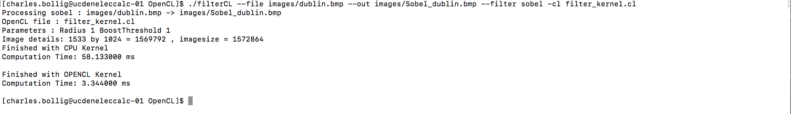

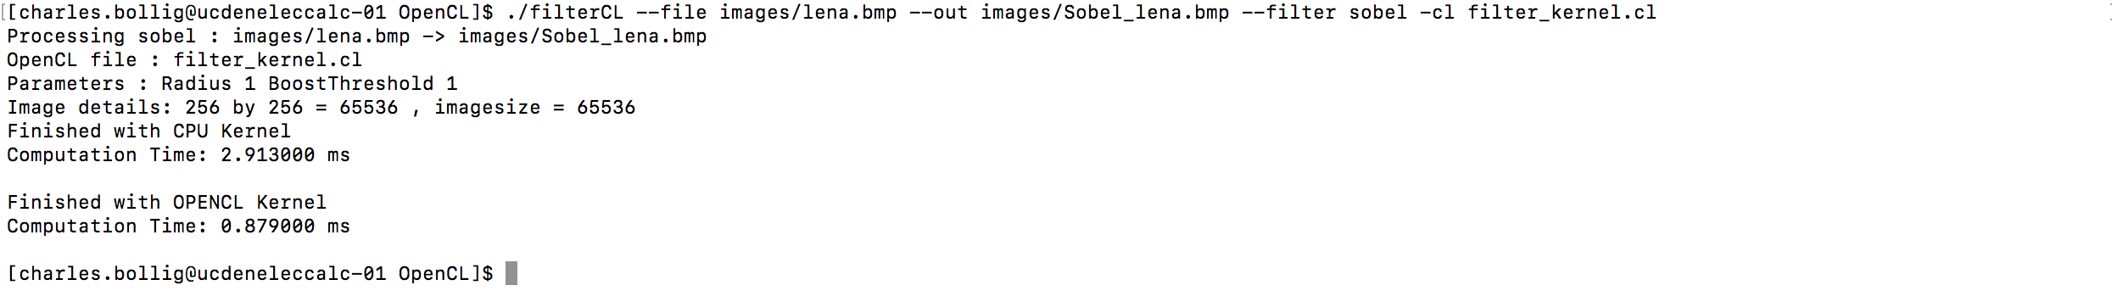

[Item 3] – Implement the Average Filter

|  |  |  |  |
| --- | --- | --- | --- |
| Input Size | OPENCL Execution Time | CPU Execution Time | Speedup (x times) |
| lena.bmp | 0.343 | 1.889 | 5.50728863 |
| dublin.bmp | 2.515 | 38.6 | 15.34791252 |

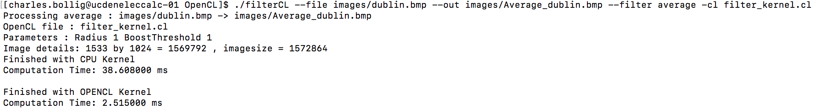

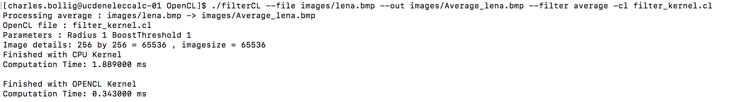

[Item 4] – Implement the Boost Filter

|  |  |  |  |
| --- | --- | --- | --- |
| Input Size | OPENCL Execution Time | CPU Execution Time | Speedup (x times) |
| lena.bmp | 0.358 | 1.919 | 5.360335196 |
| dublin.bmp | 2.66 | 41.601 | 15.63947368 |

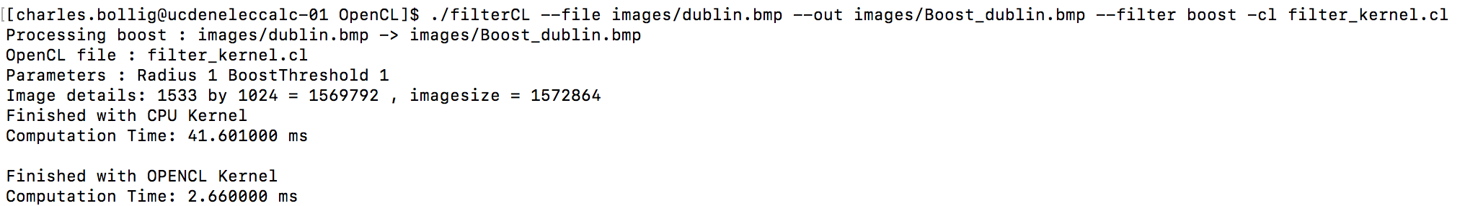

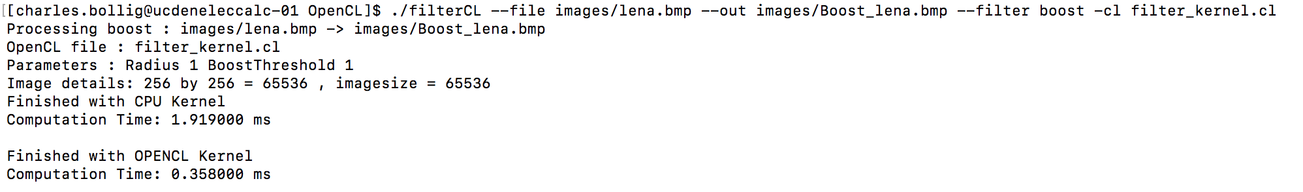

**Graduate Students-**

[Item 5] - Provide the execution time for the 5x5 Sobel filter:

|  |  |  |  |
| --- | --- | --- | --- |
| Input Size | OPENCL Execution Time | CPU Execution Time | Speedup (x times) |
| lena.bmp | 0.361 | 6.421 | 17.7867036 |
| dublin.bmp | 3.87 | 109.995 | 28.42248062 |

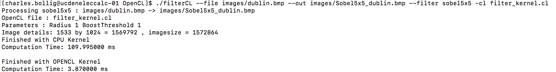

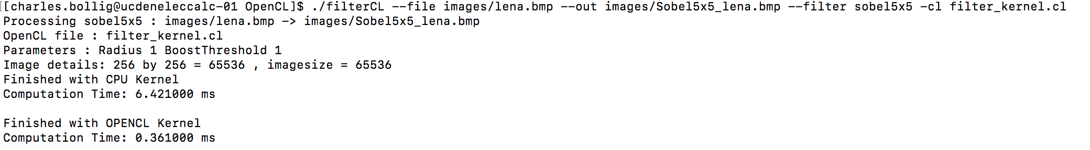

[Item 6] – Implement the 5x5 Average Filter

|  |  |  |  |
| --- | --- | --- | --- |
| Input Size | OPENCL Execution Time | CPU Execution Time | Speedup (x times) |
| lena.bmp | 0.6 | 3.412 | 5.686666667 |
| dublin.bmp | 7.124 | 66.262 | 9.301235261 |

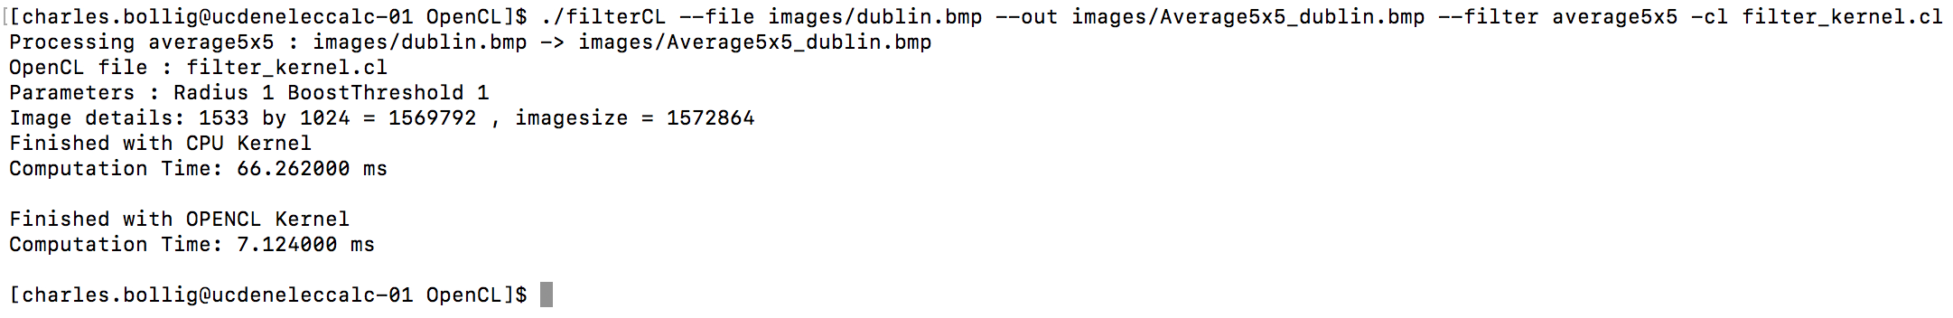

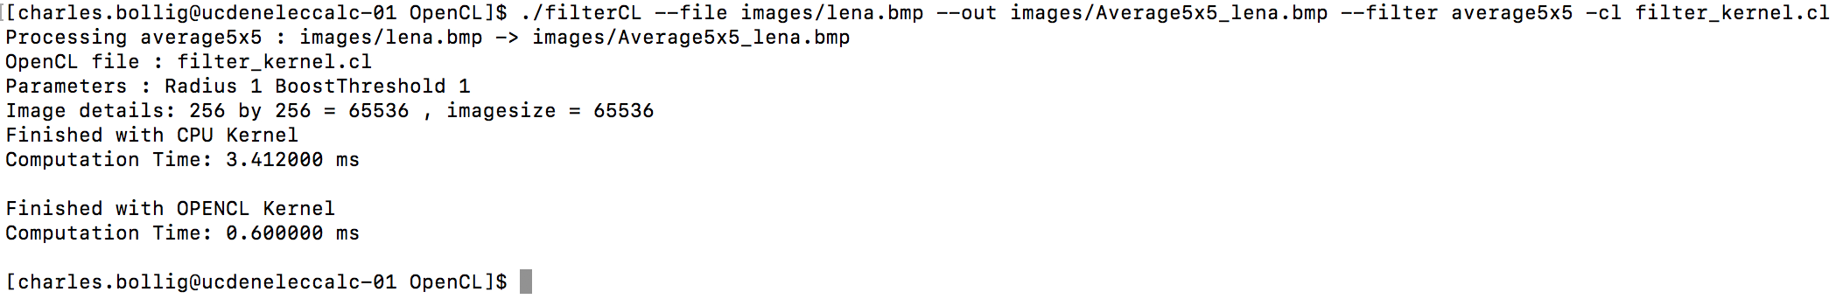

[Item 7] – Implement the 5x5 Boost Filter

|  |  |  |  |
| --- | --- | --- | --- |
| Input Size | OPENCL Execution Time | CPU Execution Time | Speedup (x times) |
| lena.bmp | 0.578 | 3.428 | 5.930795848 |
| dublin.bmp | 6.74 | 71.467 | 10.60341246 |

